City Council
2018-2019 City of Newton
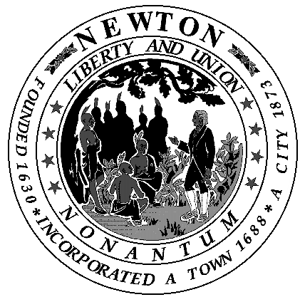

Memorandum

To: City Council
From: Chair of Public Safety & Transportation Committee
Re: Meeting Cancellation
Date: May 3, 2019

The Public Safety & Transportation Committee meeting scheduled for Wednesday, May 8, 2019 is cancelled.

The next regularly scheduled meeting is Wednesday, June 5, 2019.

Thank you

